A Simple Peer-to-Peer Energy Trading Application for Prosumers in South Florida

Hector K. Lopez  
Florida Atlantic Univeristy

***Abstract—In this paper, the problem of simple peer-to-peer energy markets is studied using a simple payment algorithm from NRG-X-change and a community based P2P market application. Prosumer networks with only solar generation and variances in performance are analyzed, specifically for historical FPL residential solar generation, resulting in poor revenue performance for individual prosumers.***

# Introduction

The original electric grid was not designed for the growing adoption of distributed generation. The smart grid is a step in the right direction, but a more distributed configuration is required to further increase reliability. The adoption of small-scale renewable energy sources and energy storage systems provide sustainable local generation for residential loads. Instead of trading bulk energy transactions over elaborate contracts between users, smart devices and distributed networks will manage high speed transactions on peer-to-peer (P2P) markets. The paper presents a brief overview of peer-to-peer markets. In the background section the current state of a prosumer payments is outlined, covering net metering and payment tiers from a select group of utilities such as Duke Energy, and Florida Power & Light. The following section provides a breakdown of Peer-to-Peer market concepts. The A P2P market application is then designed that proposes a novel smart meter enhancement for distributed communication with low costs. A real-time payment algorithm, NRG-X-Change, is used to fairly provide credits for prosumers and charge consumers [1]. A fully open-sourced containerized P2P python-based application is provided. Finally, in the results section data is synthesized for different sized prosumer networks from the EIA.gov website [1]. Payout for each prosumer is analyzed to determine the benefit of a photo-voltaic (PV) only based prosumer network.

# Background

The aging of the North American electric grid has also forced innovations in how energy is generated, distributed, and consumed. The smart grid must grow to incorporate the bi-directional flow of electricity between supply and demand sources as penetration of Plug-in Electric Vehicles (PEVs) and distributed energy resources (DERs) like Photo-voltaic Solar Panels, (PV) increases in residential sectors. The trends consist of extensive growth in small-scale distributed energy resources, which encompass behind-the-meter generation, energy storage, inverters, electric vehicles, and controllable loads such as water heaters and HVAC systems [1].With the increasing connection of renewable energy sources, traditional energy consumers are becoming prosumers, who can both consume and produce energy [2]. Growth of Clean-Tech in the Energy Sector has reduced and will continue to reduce our carbon footprint. These technologies are leveraging resources management, government regulations and demand management to achieve these results [5].



1. Increased adoption of Clean Technologies due to regulatory push to reduce carbon emissions.

Until the recent technological advances of the smart home and the smart grid, the focus for energy trading was at the level of the co-generation or power plant level. Energy would be traded amongst large regions and players with enough generation to affect the grids performance. The almost microscopic version of a residential home trading in energy storage was never designed to matter and thus very little thought has been given to energy trading markets that operate at such a small scale. The major pivot is that these smaller systems are now capable of much more inter-connected flexible and almost autonomous operation unlike today’s larger energy markets. The direct energy trading among consumers and producers is called peer-to-peer (P2P) energy trading, which was developed based on the “P2P economy” concept [4]. The flexibility in this arrangement allows for the use of market driven prices for energy in a way that has not existed before.

## Current State of Prosumer Payment

The 1968 PURPA act was enacted after the energy crisis during the 1970s. The Act would ensure that net energy up to 2MW back to the grid would be compensated at retail prices. This provides a market for prosumers to offer energy and receive payments that do not include the cost of transmission. The deferred cost of transmission means that the prosumers can get paid for electricity at a premium compared to the pricing offered to power plants and co-generation facilities. [3] Net energy metering (NEM), commonly referred to as net metering, is a metering and billing arrangement designed to compensate distributed energy generation (DG) system owners for any generation that is exported to the utility grid. NEM has been widely implemented as a customer-sited DG compensation mechanism at the state level in the United States since 1983. Currently, 41 states, in addition to Washington, D.C., American Samoa, U.S. Virgin Islands, and Puerto Rico, have mandatory net metering policies in place. Some utilities have voluntarily offered NEM arrangements to customers, as well. For example, Idaho and Texas do not have mandatory NEM policies, but some utilities in those states do offer NEM [4]. Net metering has been consistently recognized as a foundational policy to support the growth of a distributed solar marketplace [5]. NEM is easy to understand by consumers and helps to subsidize the cost of renewable installations like solar panels. The downside is that it can be a form of “cost-shifting” or subsidy for those who invest in renewables, while other unable to invest in it take the cost burden. Florida Power and Light (FPL) is a utility in Florida, U.S. that provides users in its service territory with a net metering program that allows homeowners to install and connect solar energy systems to the grid. Homeowners receive credit for the energy produced by their systems. FPL allows customers to install systems meeting up to a certain amount. The systems cannot be sized to produce energy exceeding 115% of the annual consumption, as of December 2020 [1]. Customers’ credits will be applied to their energy bill. FPL would then provide monetary compensation for any extra credits not used over the course of the year in January of each year [2]. Florida law requires that net metering customers are compensated at the retail rate. As of June 2017, retail electricity rate was 10.8 cents/kWh for residential customers using less than 1,000 kWh each month. FPL’s net metering program differs based on the size of the solar system installed. Home solar energy systems are required to fall in one of the three tiers. Each tier requires installation guidelines set by the utility. Most prosumer homes will fall within Tier 1 due to its low cost of installation and limited liability. The gross power rating or the alternating current (AC) rating for the system is the array direct current (DC) rating multiplied by 0.85. The AC rating determines the tier that the system falls under for agreement purposes. There are three tiers by system size; tier 1 is 10 kW and below, tier 2 is above 10 kW up to 100 kW, and tier 3 is above 100 kW up to 2,000 kW. The two major utilities in Florida FPL, and Duke Energy have similar NEM programs separated into tiers. The tiers are broken down by the same criteria.

| Tiers | Florida Power and Light Utility Net-Metering Tiers | | | | |
| --- | --- | --- | --- | --- | --- |
| System Size | | App. Fee | Insur. | Est. Pay |
| 1 | <10kW AC | | $0 | None | $0.11/kWh |
| 2 | 10-100kW AC | | $400 | $1M |
| 3 | 100-2,000 kW AC | | $1000 | $2M |
|  | | | | | |
| Tiers | Duke Energy Utility Net-Metering Tiers | | | | |
| System Size | App. Fee | | Insur. | Est. Pay |
| 1 | <10kW AC | $0 | | None | $0.13/kWh |
| 2 | 10-100kW AC | $240 | | $1M |
| 3 | 100-2,000 kW AC | $750 | | $2M |

In 2018, a survey done by the U.S. Energy Information Administration showed that the average home in the United States used 10,972 kWh for the entire year, which is 914 kWh each month. In Florida, the survey showed that the average home used 1,110 kWh [2]. According to the average price for FPL, retail energy has been 12 cents/kWh for the last ten years [4].

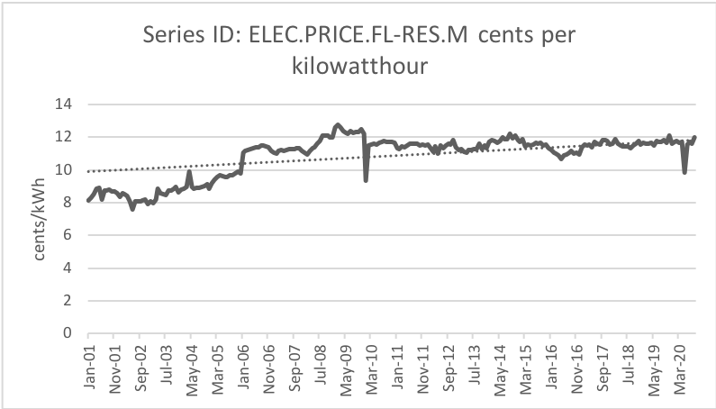

1. Retial pricing for Florida Power & Light utility collected by the United States Energy Information Administration.

Selling the surplus energy to other consumers has been a challenge for prosumers because the distribution service operators (DSO) control the energy transmission from one prosumer to the other. The community of homes would need to keep track of the energy that flowed back to the grid and match it with the consumption of the other in the community to balance the overall energy transaction as a net-zero transaction. The DSO does not isolate the cost of moving energy between a small community, instead it is tasked in distributing energy across its entire infrastructure in a balanced and reliable way. The entire cost of infrastructure maintenance is then passed on to the individual consumers equally. It is not beneficial for the DSO to have prosumers that end up not paying for energy and even making money on the infrastructure that the DSO is maintaining. The sale of energy is currently only facilitated back to the utility or service operator. A regulated utility creates other forms of compensation for excess energy generation by prosumers depending on the market and the state the utility is in.

# Peer-to-Peer Markets

With the prosumers in control of setting the terms of transactions and the delivering of goods and services [6], prosumers can gain more through trading with each other and the grid [7]. The challenge is that in a P2P network there isn’t a central authority that dictates the terms and settlement of transactions. A trustless system must be created that can simulate the needs and coordinate between competing agendas to reach a consensus for each participant while staying within the constraints of the physical systems.

## P2P Market Types

There are many different types of P2P configurations. Some of these configurations are focused on a micro-grid-based distribution system and fully decentralized control of the energy management. These *Full-P2P* configurations are suitable for isolated communities where the maintenance of all the infrastructure is maintained through self-forming coalitions. In a fully decentralized market, the bilateral contracts capture both the upstream-downstream energy balance as well as forward market uncertainty [6]. To facilitate privacy and fairness systems such as blockchain based credits are used as a distributed ledger accounting. In a *Community-P2P* a community leader is chosen to take care of the privacy and fairness. The members of the community share common interests and goals even though they are not at the same location [8] may work either in a collaborative or competitive manner. [1] Participants generally trade energy through a community manager. The community manager manages exchanges outside of the community. Privacy is preserved by the community manager [8]. A community manager may also be a federated authority that could provide maintenance and energy management. Finally, a *Hybrid-P2P* would leverage the best of both worlds and even create a hierarchal approach to stacking several Full-P2P configurations managed at a larger scale by a *Community-P2P* commission. This paper shall focus on creating a solution for the *Community-P2P* where the community leader is the utility providing an unregulated service to prosumers. A configuration where the utility is the community leader allows for the utility to participate as a prosumer with a base, or default, price for energy that includes the cost for infrastructure maintenance and energy imbalance management. *Hybrid-P2P* market combines the fully decentralized and community-based market designs. An individual prosumer can engage in P2P trading between each other, while also interacting with existing markets like fully distributed markets. [12] Community manager can also oversee trading inside the community. [13]

| Market Structure | Advantages | Challenges |
| --- | --- | --- |
| *Full P2P* | 1) Freedom of choice and autonomy, 2) Energy use aligns with preferences, 3) Complete "democratization" | 1) Investment and maintenance with ICT infrastructure, 2) Potentially slow convergence, 3) Predicting system behavior, 4) Guarantee of safety |
| *Community-based* | 1) Enhancing community relationship, 2) Mobilizing social cooperation, 3) New services for grid operates | 1) Reaching the preferences for all member all the time, 2) Aggregating all members data 3) Unbiased sharing |
| *Hybrid P2P* | 1) ICT infrastructure and computation effort are scalable to all system, 2) Co-existent design, 3) More predictable to grid operators | 1) Coordinating internal trades in the communities with trades between high level agents. |

## P2P Market Layers

The P2P energy trading markets can be segmented into a *physical*, *virtual,* and *executive* layer. Each layer contains a critical component of the P2P market structure.

1. P2P networks consist of an executive, virtual and physical layers. Each layer is essential for the successful operation of the service.

### Physical Layer

The *physical layer* is a physical network that facilitates the transfer of electricity from sellers to buyers once the financial settlements between both parties are completed over the virtual layer platform. It can be a traditional distributed-grid network maintained by the independent system operator or an additional separate physical microgrid distribution grid, in conjunction with the traditional grid. [5] Components of the physical layer consists of a DG system, a meter, a micro-controller with wireless connectivity, and a communication backhaul to other controllers such as routers, or cell towers. The metering side of the distribution has evolved from *Automated Meter Reading* (AMR) *to Advanced Metering Infrastructure* (AMI). AMI is considered Smart metering and provides utilities with bi-directional communication to the meter but also the ability of evaluating the status of the grid. Smart metering systems are equipped with smart sensors and sophisticated distributed control technology, allowing utilities to perform grid control and management. [9]

### Virtual Layer

The *virtual layer* consists of the software that facilitates interactions between participants in the market. Considerations around security, fairness and energy management is also part of this layer. It ensures that all participants have equal access to a virtual platform. The virtual platform facilitates the transfer of buy and sell orders, and financial transactions.

### Executive Layer

The *executive layer* consists of the settlements, enrollments and market relationships the P2P network must engage in. The onboarding of new participants and the interactions between the participants and the grids safe operation would be established by contractual obligations or even the initial design of the network. Some of these governmental aspects of the P2P network can be grouped under the executive layer.

1. Process of P2P energy trading walks a prosumer from enrollment to forecasting energy, transacting for the expected forecast, committing to a transaction amongst two parties, deilvering the energy and settling on the financials for each party in the transaction. This process repeats , barring the enrollment, at near-realtime rates for each prosumer.

## Existing P2P Markets

Most P2P market platforms are focused on Full-P2P solutions for futuristic infrastructure. The current focus of utilities in a regulated utilities territory such as Florida in the United States, is to harden current infrastructure from storm. Adoption of micro-grids with islanding capabilities is not as popular as the residential and commercial rate payers. Many consumers are dependent on the grid for support even when they may have DG. The advent of microgrid technology and the economic bilateral contracts has enabled the emergence of P2P markets in the energy sector. Bilateral contracts aim to increase competition in electricity markets. It is an agreement between two parties to exchange electric energy. It is a credible alternative to the pool structure used in the wholesale electricity market. Microgrids are known as low voltage grids, which are used to supply electricity to communities that can be operated in an islanding and grid connected mode. Microgrids can have dispatchable energy resources (DERs) and gain an advantage to continuing to operate in the islanding and grid connected mode [7]. The DERs are managed by prosumers in a microgrid and can sell energy back to the grid with a benefit from the Grid. The LO3 blockchain platform has been developed as a community energy market project [10]. The members can buy and sell energy from each other with smart contracts. The Brooklyn Microgrid, project used the platform to setup the virtual layer of the market as they connected the physical layer [16]. The Brooklyn Microgrid was an apartment building in New York retrofitted with roof top solar. The residents where all consumers contributing to the generation and consumption of the microgrid. The microgrid was able to be islanded off the main power grid and service the residents in a sustainable way. It was one of the few successful pilots in north America. Unfortunately, this project has yet to create a wave of adoption across the country. German platforms such as Enerchain and Sonnen charge monthly participation fees but provide blockchain based networks that protect privacy [17] [18]. Each trading platform must decide on the market strategy that will be used to pay the prosumers. A search of P2P trading platforms that focused on software with possible implementations on the existing Grid resulted in many European solutions working to establish pilots or flat fee participation on the platform. These centralized solutions allow prosumers to utilize it as a marketplace for selling energy to consumers who are seeking cheaper alternatives. They exhibit a Community-P2P structure with the organization as a community-manager that acts like a market broker. The other platforms discovered leverage blockchain but do not have an answer to the security or veracity of the metered energy when it is received or promised to be sent. These issues are not currently addressed by the platforms.

# Design of a Prosumer P2P Market

## Typical Prosumer

A prosumer can produce energy, *P1*, by conditioning it and sending it to the grid, *M1* and consuming *C1* energy from the grid when production doesn’t fully cover the load of the home.

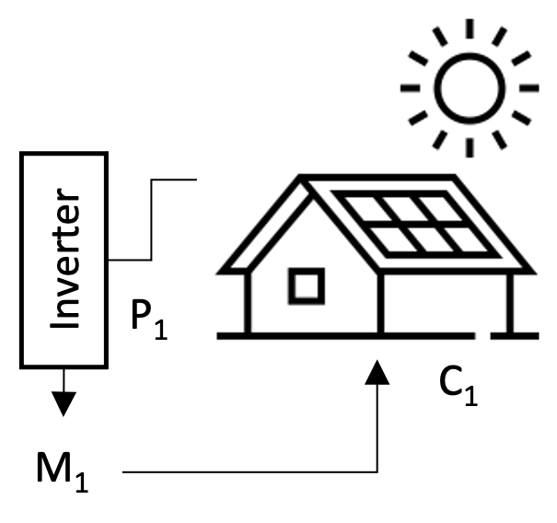

1. A prosumer configuration with solar PV

An AMI meter is connected to the homes load and measured by the utility at *M1* . An inverter is and emergency isolation switch is connected to the renewable energy sources behind the meter. The excess energy flow into the grid when it is greater than the load of the home. The utility grade meter then measures the reverse flow as net energy of the prosumer. A typical connection to measure flow independently requires expensive and time-consuming modifications to the wiring behind the meter. A novel proposal is to utilize the existing AMI form factor and implement a plug-n-play solution with a secondary unregulated meter in-between the AMI meter and the meter-can housing.

1. A typical AMI meter with a proposed P2P meter interface that would interface with pass through connectors. The P2P meter contains LTE and current sensing capabilities.

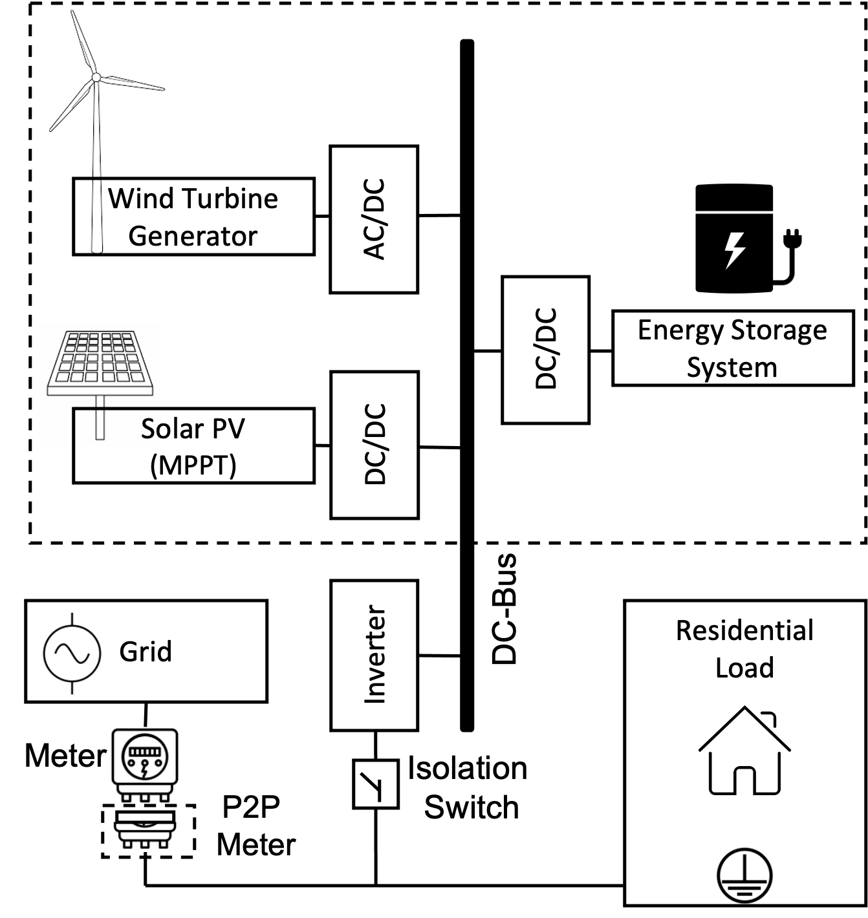

1. A typical residence with renewable power sources is connected to the sources through an inverter that converts DC to AC . The generation simulatneously feeds the load and the grid at a point of interconnection netting out the final usage of the home as positive or negative flow as measured by an electrical meter.

Typical prosumers are residential homes with different distributed generation (DG) options such as wind, solar and an energy storage system. This paper considers prosumers with only renewable energy technologies such as photo-voltaic (PV) solar panels. Additional studies would include considering PV plus storage or other combinations of DG. With PV an inverter is used to convert the direct-current (DC) generated from the PV to the alternating current (AC) required by typical house loads and the local bulk electric grid. Solar energy is an intermittent resource that is dependent on local weather and seasonality. The reduction in costs for these systems has increased the adoption rate in recent years. PV technology is simple in structure, stable in performance and does not produce any pollutants in the process of power generation; therefore, it is very suitable as a renewable power source in microgrids. It converts solar irradiation to electric, and the photoelectric effect electric current is:

$I=I_{ph}-I_{s} \left(exp\frac{q(V+IR_{s}}{nN_{s}KT}- 1\right)-\frac{\left(V+IR_{s}\right)}{R_{sh}}$



Where *q* is the electron charge, *V* is the cell voltage, and *Rs* and *Rsh* are resistance connected in series and shunt resistance, respectively. *K, T* and *n* are Boltzmann constant, operation temperature, and ideality factor of diode, respectively. Light-generated electric current is shown as $I_{ph}$ and saturation electric current is shown as $I_{s}$ .

$I_{ph}=\frac{G}{G_{ref}}\left[I_{sc}-K_{i\left(T-T_{ref}\right)}\right]$ 2

$I_{s}=I_{rs}{\left(\frac{T}{T_{ref}}\right)}^{3}\exp\left[\frac{qEg}{nk}\left(\frac{1}{T}-\frac{1}{T_{ref}}\right)\right]$ 

3

Where *G, Gref,* and *Tref* are solar irradiation, solar irradiation at standard condition, and reference temperature, respectively. The reverse saturation electric current, $I_{rs}$ is expressed as:

$I_{rs}=\frac{I_{sc}}{\exp\left(\frac{qV_{oc}}{nKTN_{s}}\right)-1}$ 4

Where *Voc* and *Ki* are open circuit voltage and short circuit current coefficient, respectively. The power of the PV model is obtained by the multiplied model current and voltage, and expressed as:

$P_{PV}=I*V$ 5

The consideration of losses in converting the PV energy to AC by the inverter is not considered as well as other minor losses due to system constraints. The ideal generation of the PV system can be modeled to understand how a typical prosumer would respond to measured irradiance in a location over time. If a series of prosumers interacted with consumers in a network the prosumers would be able to provide excess energy at times that the consumers would need it.

## Prosumer Networks

The network of prosumers and consumers could be isolated behind a substation, allowing for micro-grid isolation. The need for micro-grid isolation is optional because the network can still act as a virtual ledger managed as an unregulated service by the utility during normal service operation.

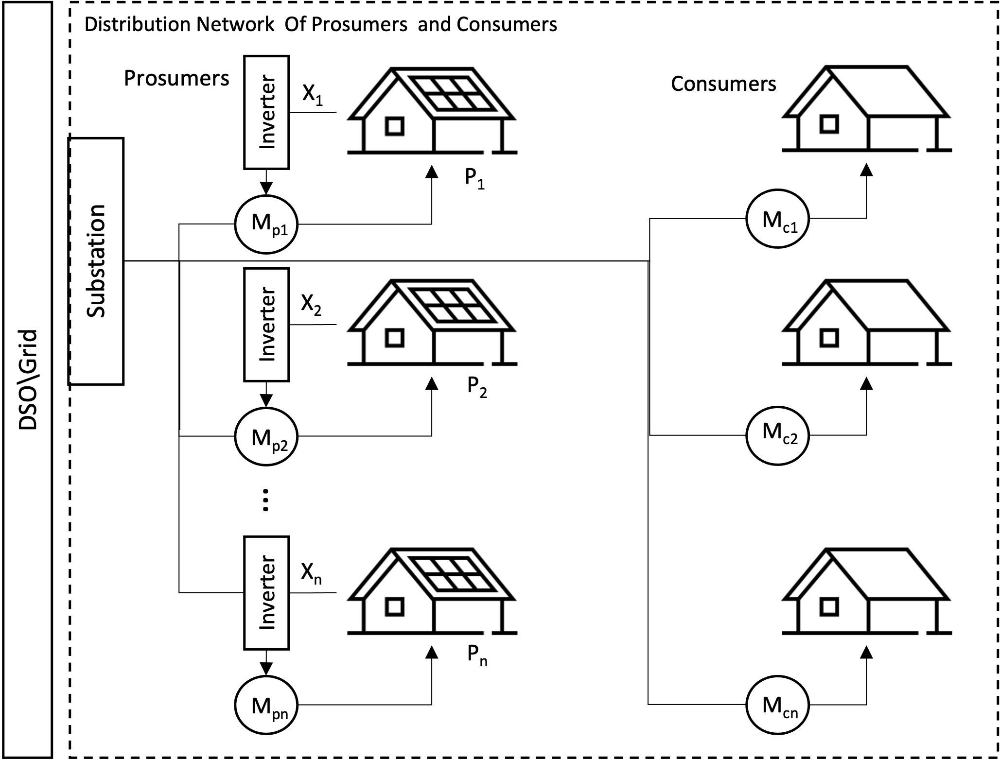

1. Network of Prosumers and Consumers feeding and recieving directly from a substation managed by a Distribution Service Operator. *M* number of participants on the network ranging from 1 to *n* number of prosumers, *p* and consumers, *c*.

A service that allows for the unregulated real-time trading of energy between prosumers and consumers can be considered a P2P market. The distribution service operator (DSO) would manage the infrastructure in both cases mentioned above. The prosumer network is represented by the set of prosumers, $P\left(n\right)$ where N is the total number of prosumers in the network.

$P(n)=\left\{P_{n=1},P_{n=2},…,P_{n=N}\right\}$



In a P2P market the prosumers excess energy is paid to the prosumer at a market price. The excess energy is referred to as net energy and it is the difference between the prosumer’s load and the prosumer’s generation. An individual prosumers net energy at some time $x(τ)$, is calculated by taking the difference between load and generation of that prosumer and clamping the value to be above 0.

$x(τ)=max(0,{P_{n}}_{load}(τ)-{P_{n}}_{gen}(τ))$



## Prosumer Payments

To pay a prosumer for the net energy, the net energy must be multiplied at some time dependent retail price, $q(τ)$. The retail price is dependent on time because it is a value that changes based on demand and costs to distribute energy. The retail price would also need to be in some monetary denomination per kWh.

$P_{n_{pay}}(τ)=x(τ)*q(τ)$



An individual prosumers payment can also be dependent on the demand so the retail price, $q(τ)$. Can be expanded to include the terms for the total generation of the network, $t_{p}$ and the total consumption of the network, $t_{c}$.

$t_{p}=\sum_{n=1}^{N}{P_{n_{gen}}(τ)}$

$t_{c}=\sum_{n=1}^{N}{P_{n_{load}}(τ)}$





Since excess energy is not valuable when there isn’t anyone to consume it, payment to the prosumer should be regulated so that the payment is based on the group contribution of energy so that it is balanced with the demand. To balance the supply and demand amongst a network of prosumers we want to compensate generation and load on the network at the correct times as proposed by the NRG-X-change mechanism [11]. A prosumers payment function is a modification of the maximum retail price at that time awarded for the energy. The individual’s contribution to in comparison to the need of that contribution is considered. The final price for the energy is then attributed to the prosumer at that time.

$g(x,t_{p},t_{c})=\frac{x*q_{max}}{e^{\frac{{\left(t_{p}-t_{c}\right)}^{2}}{a}}}$



Where the $q_{max}$, is the maximum payment for the prosumer’s energy and where $a$, is a constant that is used to tweak the distribution of the payment. A recursive function is used to home in on what an accurate constant should be for the payment function given the scale of the network. As the disparity between the single prosumer and total load and generation could be the scale factor should be adjusted. Implementing a sensitivity analysis of the scaling factor $a$, with respect to the net energy squared reveals that the scaling factor should be greater than or equal to the net energy squared, but the small enough to not become undefined.

A consumer payment function is considered in a similar way. The prosumers or consumers that require to draw energy from the network would be charged according to the overall demand. The price of energy increased based on the demand forcing the behavior to change for consumers who do not wish to pay for higher prices at the demanded time.

$h(y,t_{p},t_{c})=\frac{y*r_{max}*t_{c}}{t_{c} + t_{p}}$



Where $r_{max}$ is the maximum cost of energy delivered by the DSO when the energy supply by the prosumers is low. When the production matches consumption the substation will charge $\frac{r_{max}}{t_{c}}$ per kWh.

## Prosumer Market

The NRG-X-change protocol proposes an interchange of energy transactions leveraging a DSO as an intermediary and broker for the market. (NRG,) The advantage of this design is that it creates more privacy for the participants of the service, and it gives control to the DSO to implement incentives for ancillary services. Approaches that leverage blockchain technology help to increase security and privacy for each person on the network. The costly implementation of blockchain however continues to be an area of research. The transactional speeds slow down as the network grows and the complexity of implementing a viable blockchain network requires expertise by the prosumers that can be more costly than the service. To keep costs low hybrid P2P architecture is proposed. Prosumers would have a community manager initiate a software application under and organizational account with a reliable cloud hosting vendor. The market transactions would occur entirely on the market application. The metered energy flow would be sent to the application and a centralized ledger would be kept of the payment and cost for the energy on the network. Payment for each prosumer is calculated in real-time by the broker using the NRG-X-change algorithm and recorded so that the settlement is provided to the prosumer and consumers that participate in the network.

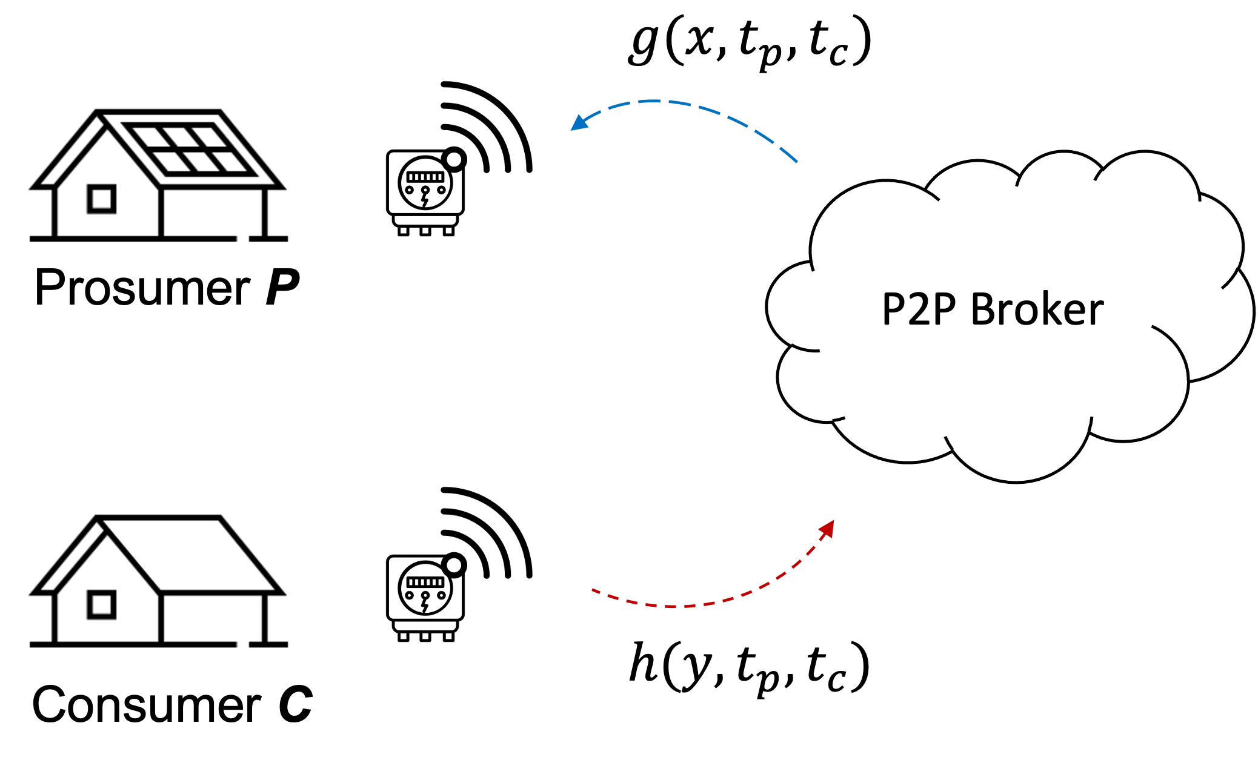

1. Enrolled prosumers and consumers send transaction information that is then paid using the revenue , g(.) and cost , h(.) algorithms.

# Implementation

## Design Overview

A proposed implementation of the communications of a P2P market is to include an IoT capable meter with access to a wireless cellular connection. The meter would measure the power in kilowatts consumed or produced at the point of interconnection with the grid. The meter would then send messages to the P2P broker. The messages are sent over the proposed P2P meter using a wireless backhaul such as LTE-M or LTE. Each P2P meter would send messages over an OASIS standard messaging protocol for the Internet of Things (IoT) called MQTT. It is designed as an extremely lightweight publish/subscribe messaging transport that is ideal for connecting remote devices with a small code footprint and minimal network bandwidth [12].The messages contain simple record structure to identify the Customer Id, and the kilowatts associated with the meter, finally a timestamp would be sent along with the message to accurately track the flow of energy. The messages arrive at the publicly available MQTT broker endpoint. The messages are then sorted by timestamp into a stream and processed to determine the payment or billing amount for each customer at every associated timestamp. At any given time, the balance of the customers would be available on a management portal.

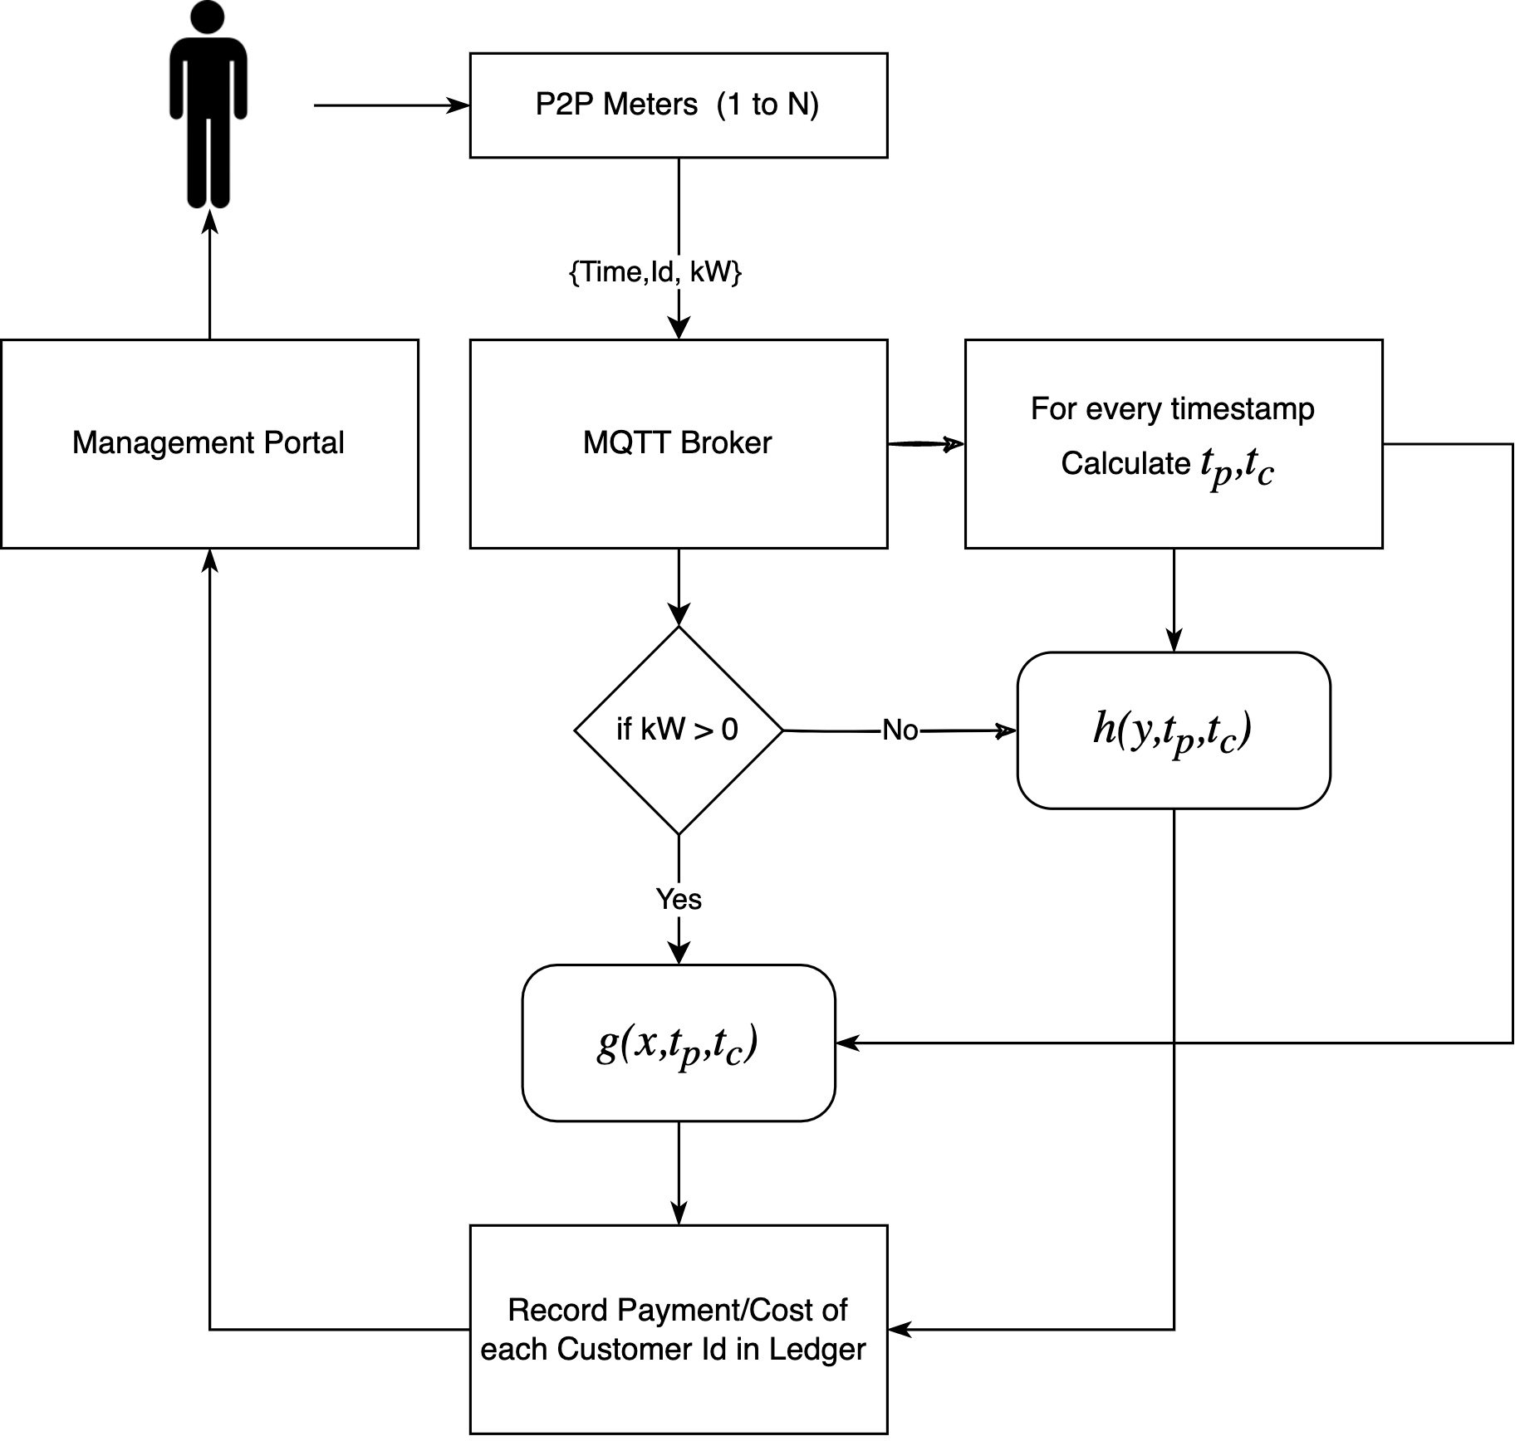

1. Simplified flow chart of P2P application leveraging NRG-X-Change algorithm for prosumer payment and billing.

## Message Structure

The MQTT messages are encoded as binary messages. The P2P meter would send the values to the broker as an encoded string with any series of information within it. To make the simulation simple the use of JSON (Java Script Object Notation) is used to define a message structure. An additional feature that is proposed that is not normal for IoT operations is the use of a “quality” code value. The quality code is used in industrial protocols to define low level health status of devices. These quality codes are well defined in Industrial Control System protocols such as OPC, OPCUA, and DNP3. The quality of a given OPC tag is used to represent the validity of the tag's value (in other words, whether a client can trust the data). OPC quality is divided into three main categories: Good (generally indicates the data is valid), Bad (generally indicates the data is not valid), or Uncertain (generally indicates the data is speculative in some manner). Each category is further divided into sub-categories; the exact criteria for using a particular sub-category may vary depending on the end protocol and vendor. The value for the timestamp should be chosen to be a point in time counter type time designation to avoid issues with time zones such as the Unix time (also known as Epoch time, Posix time) that is widely used in operating systems and file formats. Finally, the value for the energy is chosen to be a positive or negative value defined as a floating-point value of kilowatt.

{

'time': 1637984408,

'qos': 0,

'id': 1,

'kW': 0.12,

}

1. JSON formatted P2P meter message structure with sample values for each field, time is the timestamp of the message as unix time, qos is the quality code, id is the customer identifier, and the energy is defined as kW.

## Message Processing

The records arrive on the message broker in asynchronous order. The MQTT protocol allows for the messages to arrive at a given ‘topic’ that any MQTT client can subscribe too and listen to messages as they arrive on the topic. The published messages are available for the subscribed client. The client subscription requires the defined broker endpoint, the port that is typically 1883, and a name for the connecting client. An example of the mosquito MQTT application is shown to indicate how a user can test the submission of the message through a command line.

mosquitto_pub -t INFO -m '{"time": 1637984408, "qos": 0, "id": 2, "kW": 0.173}'

1. Example of a paho mosquitto MQTT terminal console command to publish a test message to the INFO topic on a local broker.

## P2P Broker Awaiting Messages

A more exhaustive script is if leverages the paho MQTT Python library to simulate a subscription to the broker at the given topic. The main method handles the long running task and loops forever expecting messages to arrive on the broker from P2P meters. The override function ‘on_connect’ determines what happens when a successful connection is established.

import threading

import paho.mqtt.client as mqtt

import json

import pandas as pd

import time

mqttBroker = "localhost"

mqttPort = 1883 *# port for mosquitto broker*

client = mqtt.Client("p2p-broker") *# new instance*

msg_dict = [] # create a list to store the messages

def main():

*# Define callback function for success connection*

client.on_connect = on_connect

*# Define callback function for receipt of a message*

client.on_message = on_message

*# Connect to the broker*

client.connect(mqttBroker, mqttPort, 60)

*# Start networking daemon*

client.loop_forever()

def on_connect(client, userdata, flags, rc):

print("Connected with result code {0}".format(str(rc)))

client.subscribe("INFO")

1. Python script showing the main entry point for an MQTT client connecting and subscribing to the P2P broker (hosted locally).

The client also overrides the “on_message” method so that the processing of the incoming messages is performed. The method converts the binary string into a JSON formatted object and stores it as a record in a thread safe list. A separate thread is invoked that loops every few seconds and processes the messages into the total production and total consumption grouped by the time interval. The methods also remove any duplicate messages that arrive on the broker based on timestamp and customer Id. This forces the messages to be unique. Note, that the synchronization of messages from each meter is not considered. The assumption is that all messages will arrive at a synchronized clock rate, i.e. once per second. If the messages are out of sync the aggregation of energy supplied or consumed may not be as accurate. Aggregating towards a common time window or even creating back casting methods to smooth out errors would result in more robust energy attribution across the network.

def on_message(client, userdata, msg):

# convert msg to json

data = json.loads(msg.payload)

# check if data is in dict

if not any(msg['time'] == data['time'] and

msg['id'] == data['id'] for msg in msg_dict):

# store data in a dictionary

msg_dict.append(data)

def thread_process_msgs(id):

while True:

try:

df = pd.DataFrame.from_records(msg_dict)

tp = df[df['kW'] > 0].

groupby(['time']).sum()

tc = df[df['kW'] < 0].

groupby(['time']).sum()

# itterate through values of tp

for index, row in tp.iterrows():

# update df with tp at time index

df.loc[df['time'] == index, 'tp'] = row['kW']

for index, row in tc.iterrows():

# update df with tc at time index

df.loc[df['time'] == index, 'tc'] = row['kW']

time.sleep(2)

df = calculate_nrg(df)

except Exception as e:

print(e)

1. Python methods demonstrating a threaded process that reads messages on a list and aggregates the total production and consumption of each group at the given time interval the messages where sent.

## P2P Broker Calclating NRG-X-Change

The payment and billing functions as described by the NRG-X-Change [13] algorithms are implemented on a central broker then provided to consumers as the final payment or bill that should be issued. This method is simpler than creating a blockchain based network and is a lower cost and lower complexity implementation at the sake of decentralization. The payment calculation is done on the P2P broker and is done at a configured rate. The configuration for the scaling factor and the max price of produced and consumed energy must be set by the community manager of the P2P network. In this example the defaults are set in the script based on historical max and min pricing from the synthesized dataset.

*# NRGXChange Payment g(.) Function*

# price : the maximum price for energy produced

# tp : the total production of the network

# tc : the total consumption of the network

# a : scaling function

# n : number of particpants on the network

def g(price, X, tp, tc, a, n):

q = price

try:

pay = (pow(X, n)*q)/math.exp(pow((tp-tc), 2)/a)

except OverflowError:

pay = float('inf')

return pay

*# NRGXChange Charge h(.) Function*

# price : the maximum price for energy consumed

# tp : the total production of the network

# tc : the total consumption of the network

def h(price, Y, tp, tc):

r = (0.01*price)

try:

cost = (Y*r*tc)/(tc+tp)

except OverflowError:

cost = float('inf')

return cost

1. Python scripted payment and cost functions for prosumers and consumers conversion of *X*,produced energy and *Y*, consumed energy.

## P2P Broker Management and Visualization

Cloud services provide scalable, reliable, robust solutions that can be secured for privacy. A containerized approach to the application would allow the application to be hosted on any cloud vendor. The P2P application would manage the enrollment, pricing, and settlement of the energy for each prosumer. By allowing the application to be configured the community manager can adjust max retail electricity costs and payments from the DSO. The architecture utilizes MQTT to facilitate a publish/subscribe style of communication. The transaction of the system is brokered and recorded through various microservices. The design can be scaled and distributed across agents. Leveraging the scalability of the cloud to support a growing P2P network. The architecture can be described as a monitoring stack and a management stack with a transactional layer.

### Monitoring Stack:

Comprised of opensource software that reads in messages through “Filebeat” an agent that can receive MQTT messages from a MQTT broker on the transactional layer and relay it to “Elastic” an opensource unstructured database. The final component is “Kibana” a dashboard visualization application that could provide event level details of each event for monitoring.

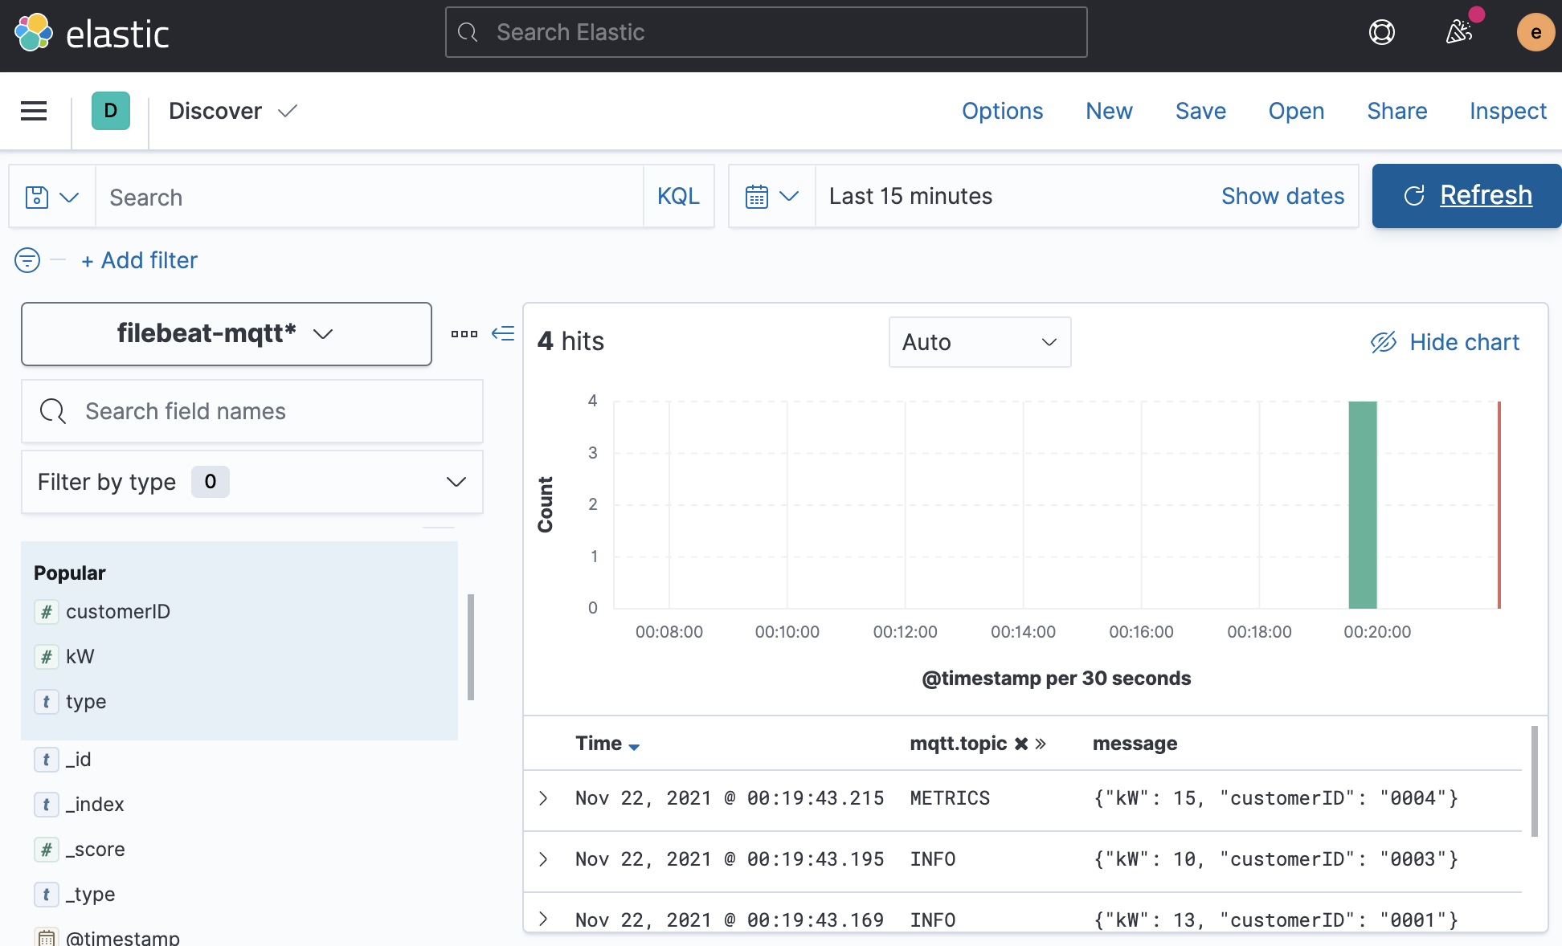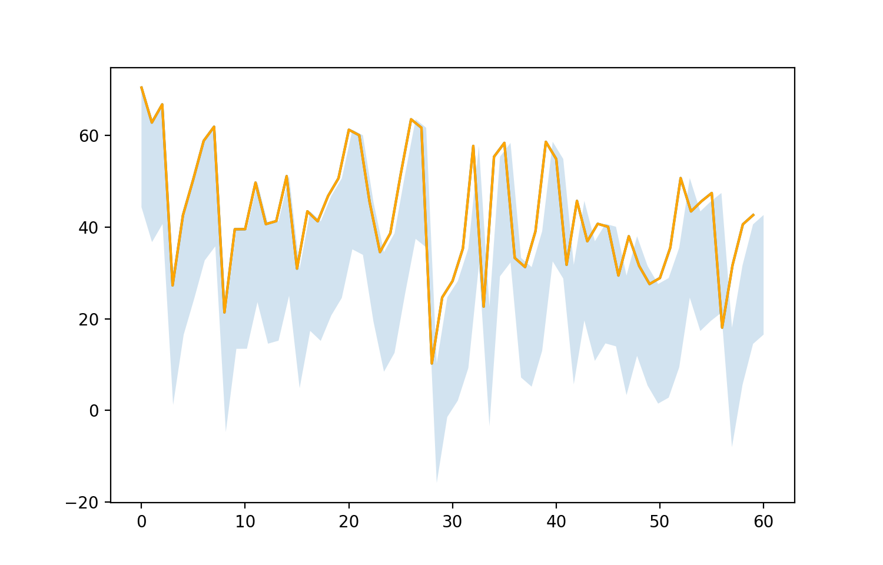

1. Elastic Dashboard and transactions showing the particpants submit customer IDs and the corresponding kWh reading to the broker.

### Management Stack:

Is used to implement management roles such as enrollment, configurations, and adjustment. It can also host a public website as a portal for participants to look at what the balance is and adjust account settings. This layer relays all changes to the MQTT broker in an asynchronous manner to the monitoring stack. The most important component is the “Broker”, a custom agent that performs the energy balancing and ancillary energy management services between all the participants of the network.

### Transactional layer:

A layer that facilitates communications between participants and the management and monitoring stacks. It is made of MQTT broker that is opensource by Mosquitto.org, the exchange information can be asynchronous and passed rapidly using “publish” and “subscribe” transactional messages between the participants and the stacks. This methodology allows for distributed communications.

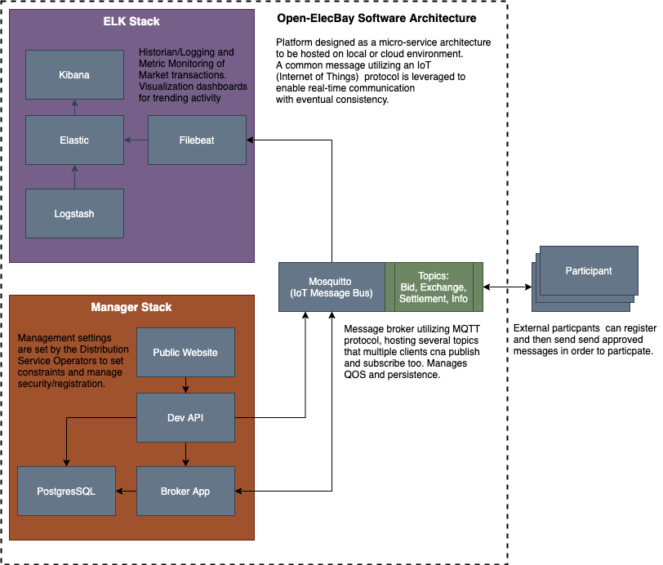

1. Microservice based software architecture diagram for P2P market broker application with management console.

# Results

To simulate the results of the system data was synthesized from annual consumption trends and the regulatory constraints of the geographical region of Florida. The assumptions around the size and limits to PV systems were considered based on sources from EIA.gov [3] and NREL (National Research Energy Labs). The synthesized data was then used to generate results of prosumers payback for a network of N=3 prosumers and for a network of N=100 prosumers. The prosumers would consume a load first and then provide any excess generation. The variations in generation and consumption are modeled with a statistic variance to cover variations in home sizes, location, losses, and other performance considerations. Future works would consider the integration of energy storage alongside the PV generation that could offset generation capacity allowing for greater revenue opportunities.

## Synthesizing Data for Florida Prosumers

The data used in the simulation is provided by the U.S. Energy Information Administration [3] API (application programmable interface). The dataset is filtered for the Florida Power and Light service territory. The two datasets requested are for load demand and solar generation. The prosumers load demand must be derived statistically since an individual’s load is not made available through public datasets. The average use of a single prosumer can be inferred at a monthly time range but not on a daily or hourly time. The average monthly estimate for a prosumer in the FPL territory; 1,110 kWh/month [2]. The hourly and monthly load demand is publicly available data, but it is on an aggregate. To be able to use this data normalize the aggregate usage over a time window then multiply the estimated mean usage by each of the normalized samples over the time window. The result would be a load demand curve that estimates a typical prosumer load demand about the average load. The 1100kWh per month was divided by 730 hours in a month to arrive at a 1.5kW load at each hourly sample. The normalized curve was mapped against the load with two standard deviations as an error. Note that the figure below shows the values for two months, the start of January 2020 and end of February 2020.

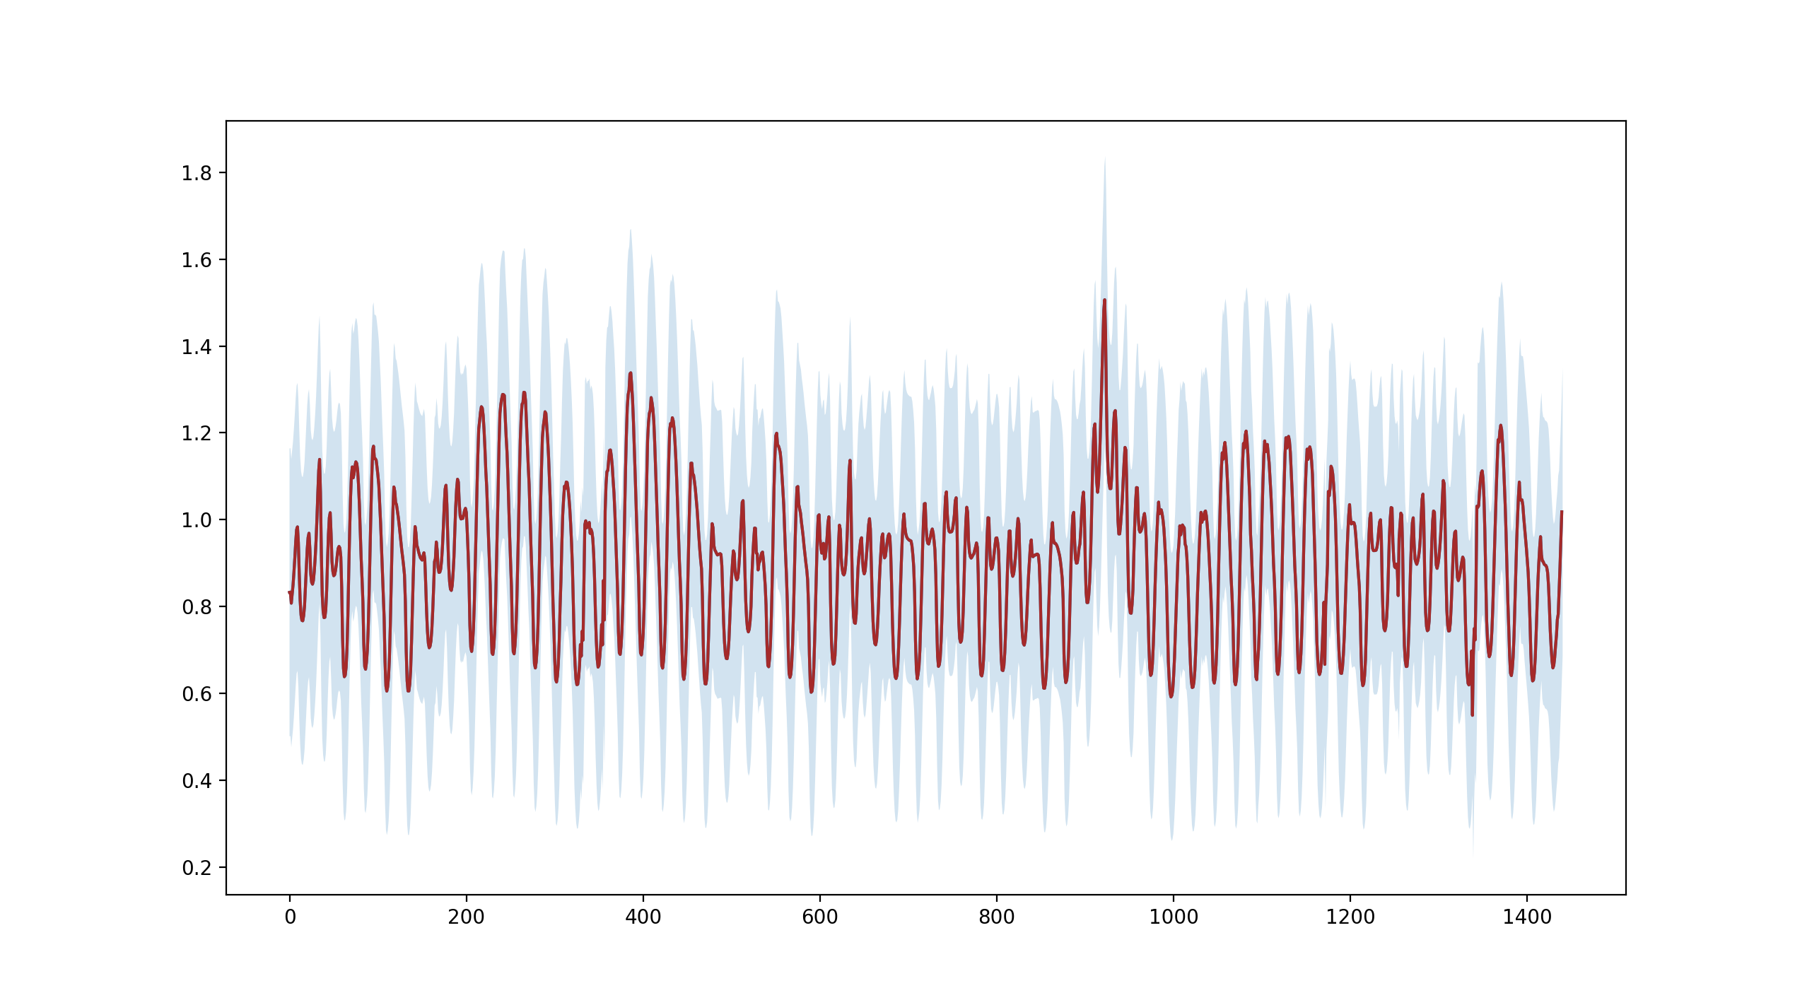

1. Hourly load demand (kWh) about an average prosumers load of (1100kWh/730h) between Jan. 2020 and Feb. 2020 with an error band of 2 standard deviations.

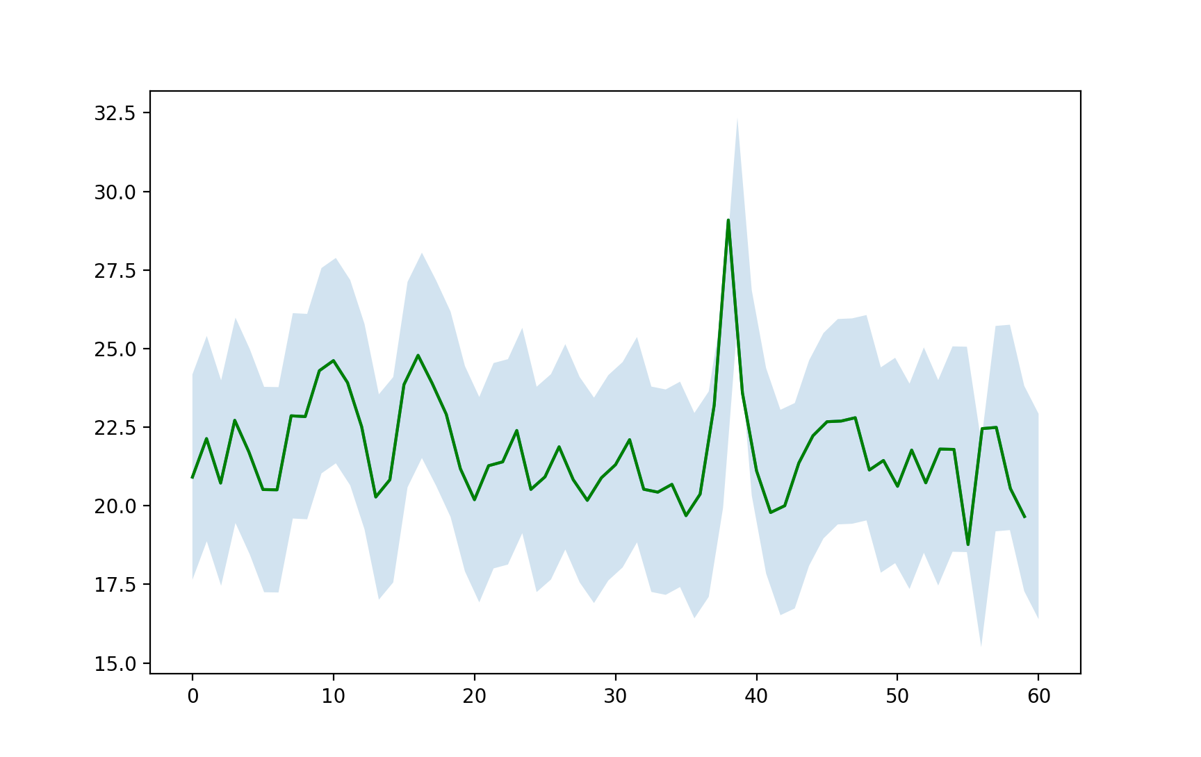

1. Daily load demand of a typical consumer that draws an average of 1100kWh a month correlated to the normalized curve of overall demand between January 2020 and end of February 2020.

The approximation provides a starting point to model a prosumers daily consumption. The prosumers variance of consumption is considered as two standard deviations from the mean but can be adjusted in future research. The actual load demand of individual users can be utilized instead of this approximation into the model for better results. In this research we will assume PV is utilized by the prosumers, but this can be adjusted to be different types of generation with different driving renewable energy curves. The total solar generation of the FPL territory is an indicator of the potential capacity of a prosumers much smaller generation. The assumption is that the total correlation of solar generation on aggregate is proportional to the solar generation at the prosumer level.



1. Daily generation of a Tier1 solar system installed on a a typical prosumer as a proportional correlation to the normalized curve of FPL’s overall generation from solar start of January to end of February, 2020.

## Prosumer Network Revenue N=3, N=100

The analysis shows the positive and negative transactions for the energy generated by each of the prosumers. The prosumer revenue for id=3 generated the most revenue over the course of the year. The analysis shows that with only PV the network is dependent on variance in load and generation performance. At larger networks the revenue per prosumer tends to decrease. The variance in performance for each prosumer works against the revenue gains for each prosumer across the network.

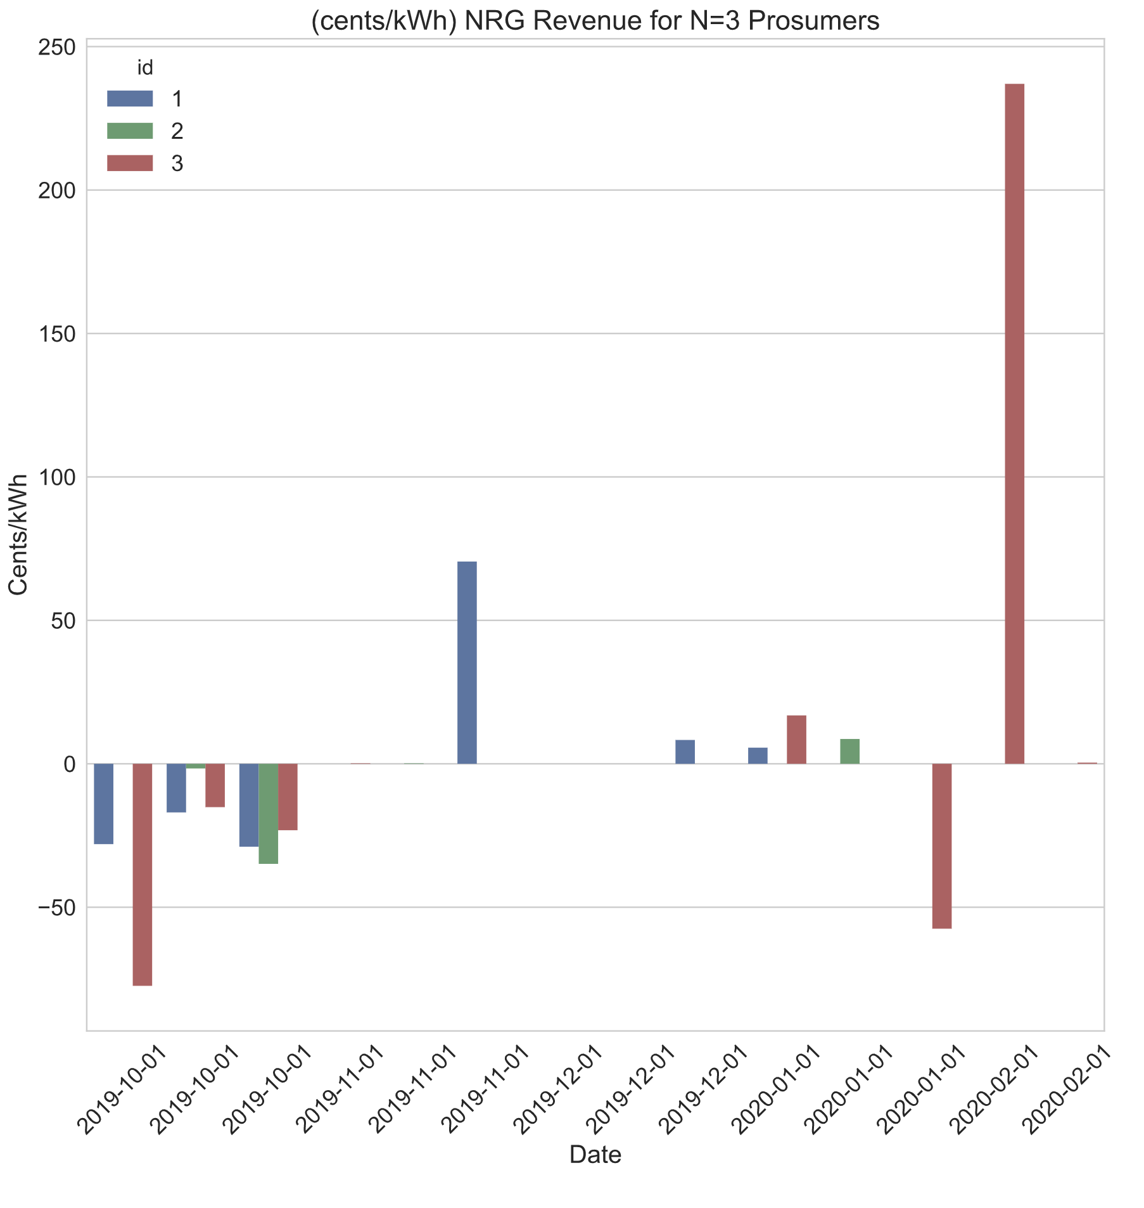

1. Hypothetical generation of Prosumers in a network of N=3 using NRG-X-Change mechanisim for the FPL synthesized data; start of January to end of February, 2020.

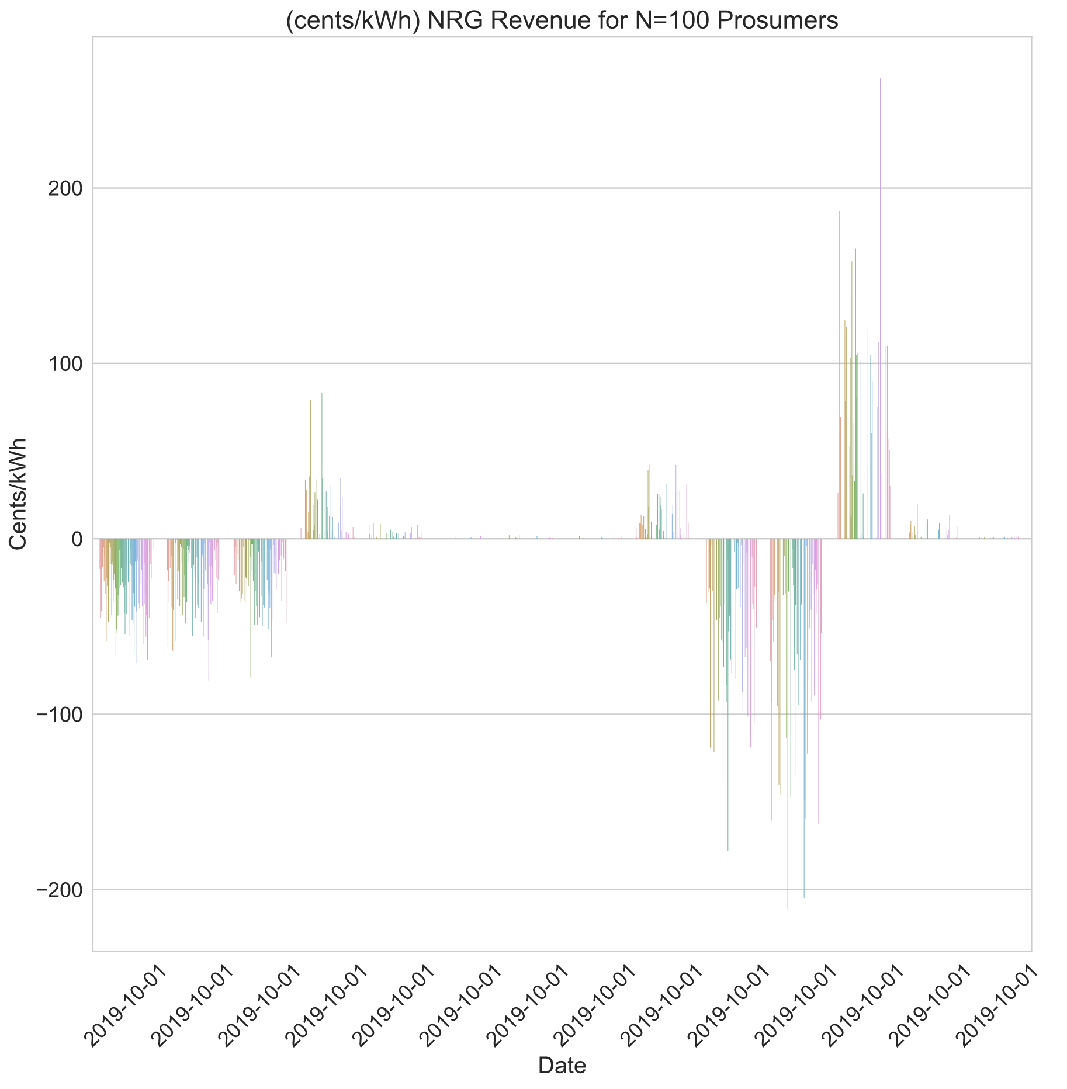

1. Hypothetical generation of Prosumers in a network of N=100 using NRG-X-Change mechanisim for the FPL synthesized data; start of January to end of February, 2020.

# Conclusion

The paper covered an overview of P2P networks and the types of P2P networks. A breakdown of the physical, virtual, and executive layers of a P2P market was covered. A proposal for a novel P2P meter leveraging existing AMI meter form factor was described so that future implementations could avoid costly permits and modifications to existing infrastructure. A prosumer with a PV generation source was used to model a typical prosumer and prosumer network­. The implementation of a P2P prosumer market was designed to be managed by a community manager. The design of an application that can leverage scalable cloud services and monitoring tools using opensource software was described. Core methods describing the use of real-time payment scheme derived from NRG-X-change was reviewed. Finally, a simulation leveraging synthesized data from EIA.gov and NREL shows the results of revenue for prosumers based on networks of N=3 and N=100. The variance in these prosumer networks was statistically modeled to cover variances in home size, performance, and other losses. It turns out that with just PV and variances in performance larger networks are less likely to provide significant revenue for individual prosumers. Future works would include the implementation of energy storage systems alongside PV for prosumers.

# References

|  |  |
| --- | --- |
| [1] | J. S. ,. V. M. K. ,. A. N. ,. N. A. Mihaylov Mihail, "NRG-X-change a novel mechanism for trading of renewable energy in smart grids," in *Proceedings of the 3rd International Conference on Smart Grids and Green IT Systems*, 2014. |
| [2] | U. E. I. Administration, "eia.gov," October 2008. [Online]. Available: www.eia.gov. [Accessed 1 11 2021]. |
| [3] | T. K. S. C. Y. T. M. M. D. M. H. V. P. K. L. W. W. Tushar, "A motivational game-theoretic approach for peer-to-peer energy trading in smart grid," *Applied Energy,* vol. 243, pp. 10-20, June 2019. |
| [4] | D. P. Luo Y., "Autonomous Cooperative Energy Trading Between Prosumers for Microgrid Systems.," in *3rd IEEE International Workshop on Global Trends in Smart Cities go SMART*, 2014. |
| [5] | J. Hamari, M. Sjöklint and A. Ukkonen, "The Sharing Economy: Why People Participate in Collaborative Consumption," *Journal of the Association for Information Science and Technology,* vol. 67, no. 9, pp. 2047-2059, 2016. |
| [6] | J. Cummings, "SIRE: Database of State Incentives for Renewables and Efficiency (Website Review)," *Reference Reviews,* vol. 23, no. 10.1108/09504120910969131. , pp. 44-45, 2009. |
| [7] | D. E. Krasko V., "Strategic Sequencing for State Distributed PV Policies: A Quantitative Analysis of Policy Impacts and Interactions.," National Renewable Energy Laboratory, Golden, Colorado, 2012. |
| [8] | N. F. S. J. D. M. D. M. T. Morstyn, "Using peer-to-peer energy-trading platforms to incentivize prosumers to form federated power plants," *Nature Energy,* vol. 3, no. 2, pp. 94-101, 2018. |
| [9] | C. Y. H. M.-R. T. S. H. V. P. ,. K. L. W. W. Tushar, "Transforming Energy Networks Via Peer-to-Peer Energy Trading: The potential of game-theoretic approaches," *IEEE Signal Processing Magazine,* vol. 35, no. 4, pp. 90-111, July 2020. |
| [10] | Q. A. J. Ni, "Economic power transaction using coalitional game strategy in micro-grids," *IET Generation, Transmision Distribution,* vol. 10, no. 1, pp. 10-18, 2016. |
| [11] | H.-C. L. V. D. A. I. Uribe-Perez Noelia, "State of the Art and Trends Review of Smart Metering in Electricity Grids," *Applied Sciences,* vol. 6, no. 10.3390, pp. 68-92, 2016. |
| [12] | V. D. M. A. Sakineh Khalili, "Impact of Blockchain Technology on Electric Power Grids - A case study in LO3 Energy," *ConnectSmart Research Laboratory,* vol. University of Tenesee at Chattanooga, 2020. |
| [13] | S. Vottem, "Application of Cooperative Game Theory in Smart Grids," in *Texas State University*, San Marcos, Texas., 2019. |
| [14] | E. K. M. O. P. ,. G. C. M. Bender, "Open-Source MQTT Evaluation," in *2021 IEEE 18th Annual Consumer Communications & Networking Conference (CCNC)*, 2021. |

1. Wayes Tushar, Peer-to-Peer Energy Systems for Connected  
   Communities: A Review of Recent Advances and  
   Emerging Challenges
2. https://www.fpl.com/clean-energy/net-metering/guidelines.html
3. Sage LLC. “Market Research on FPL” Sunshot U.S. Department of Energy https://www.energysage.com/local-data/net-metering/fpl
4. The Public Utility Regulatory Policies Act of 1978; Sarah Czufin, Government Relations Director.
5. Atzeni, L. G. Ordòñez, G. Scutari, D. P. Palomar, and J. R. Fonollosa, “Demand-side management via distributed energy generation and storage optimization,” IEEE Trans. Smart Grid, vol. 4, no. 2, pp. 866–876, June 2013.
6. Dimeas, A.L.; Hatziargyriou, N.D. Operation of a multiagent system for microgrid control. *IEEE Trans. Power Syst.* 2005, *20*, 1447–1455.
7. Prinsloo, G.; Mammoli, A.; Dobson, R. Customer domain supply and load coordination: A case for smart villages and transactive control in rural off-grid microgrids. *Energy* 2017, *135*, 430–441.
8. Pei, W.; Li, S.; Li, H.; Tang, X.; Cheng, J.; Zuo, W.X. Key technology and testbed for micro-grid operation control. *Au- tom. Electr. Power Syst.* 2010, *34*, 94–98.
9. Nakamoto, S. Bitcoin: A Peer-To-Peer Electronic Cash System. 2008. Available online: https://bitcoin.org/bitcoin.pdf.
10. Ethereum Community. A Next-Generation Smart Contract and Decentralized Application Platform, White Paper. Available online: https://github.com/ethereum/wiki/wiki/White-Paper.
11. Zhuo, N.; Muyang, L. LIP-Chain: A Logistics Information Platform Based on Permissioned Blockchain. Comput. Technol. Dev. 2019, 29,190–194.
12. Novo, O. Blockchain meets IoT: An architecture for scalable access management in IoT. IEEE Internet Things J. 2018, 5, 1184–1195.
13. Thomas Bennett, Ali Zilouchian, Roger Messenger,Photovoltaic model and converter topology considerations for MPPT purposes, Solar Energy, Volume 86, Issue 7, 2012, Pages 2029-2040, ISSN 0038-092X, <https://doi.org/10.1016/j.solener.2012.04.005>.
14. (2016). "The Sharing Economy: Why People Participate in Collaborative Consumption". Journal of the Association for Information Science and Technology. 67 (9): 2047–2059. doi:10.1002/asi.23552